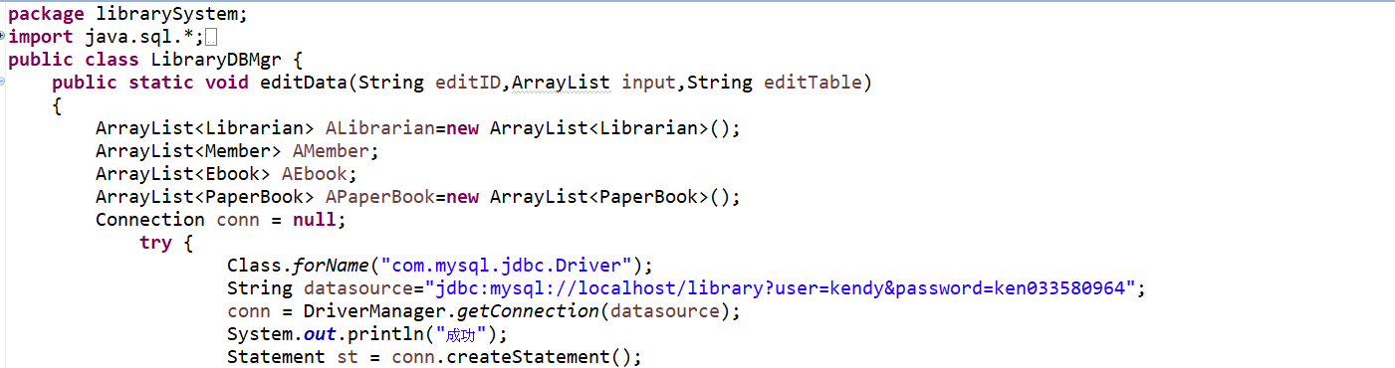

I get an ArrayList it’s name is input and I have an ArrayList<Member> it’s name is AMember

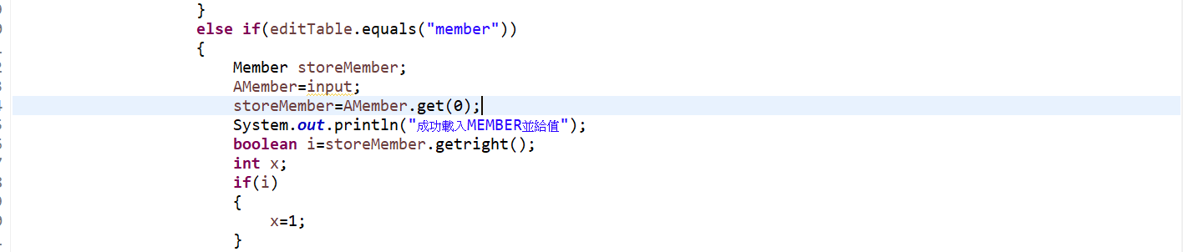

I have a Member it’s name is storeMember and then I let ArrayList<Member> AMember equal to input(let input’s type to Member) and get first AMember’s Array

to storeMember

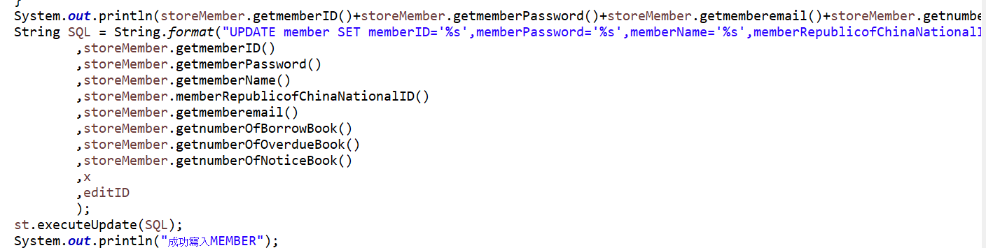

use Member’s function.

Cohesion

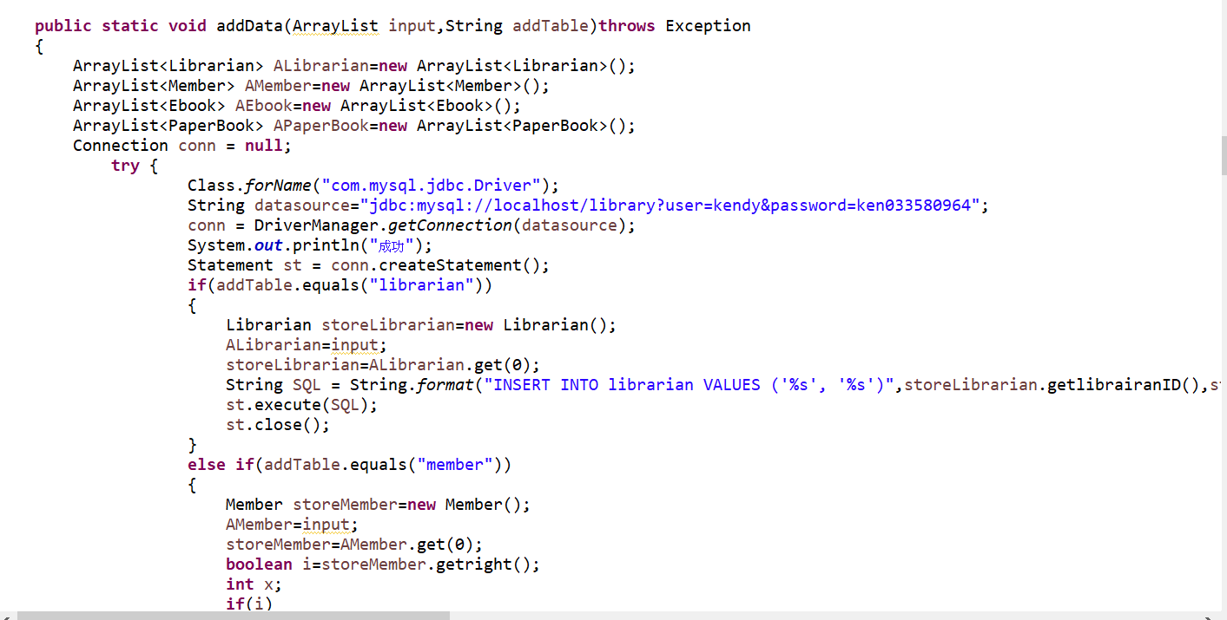

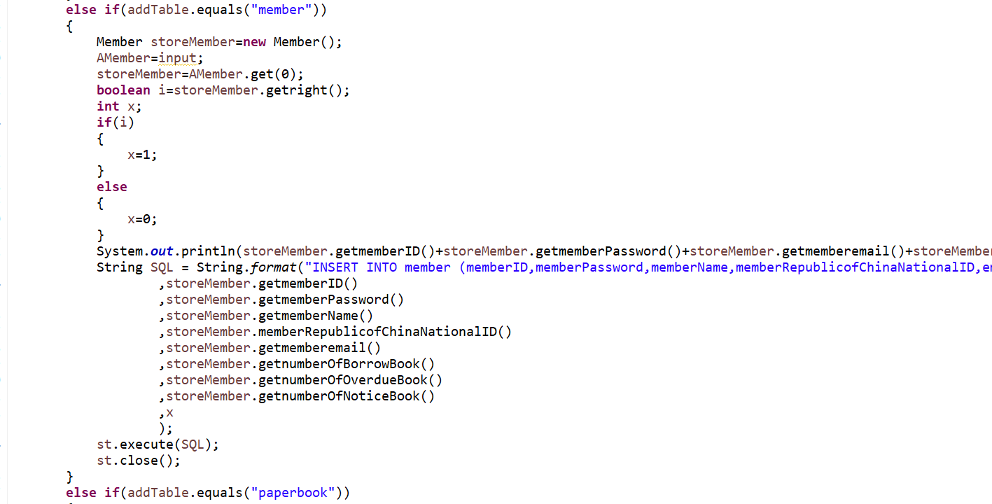

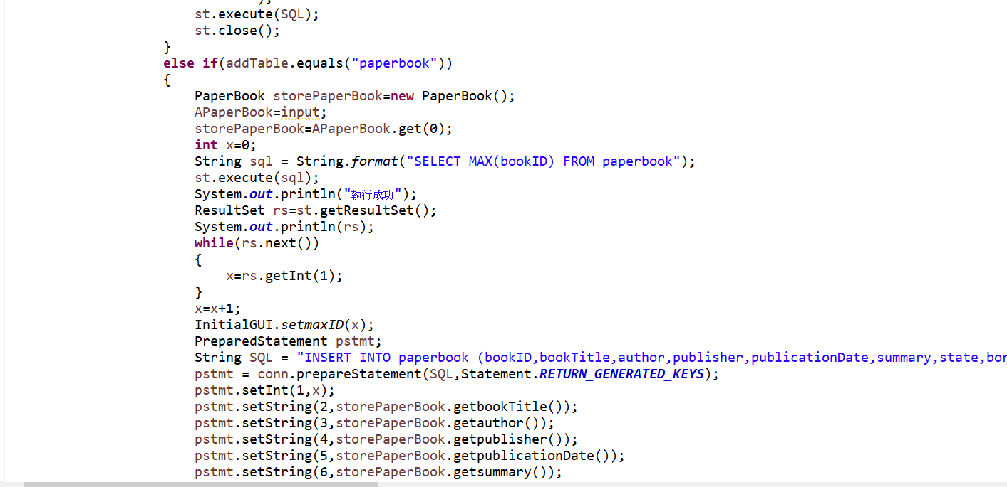

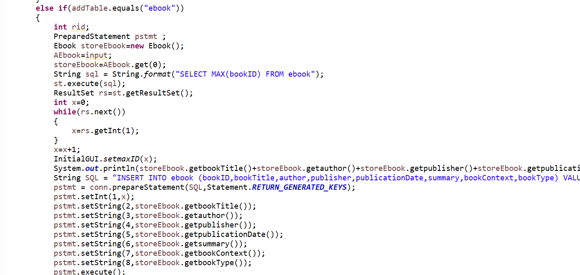

addDate method can add four data there are member、librarian、paperbook、ebook。